New York State Social Studies Learning Standards

Standard 1:   | History of the United States and New York  Students will use a variety of intellectual skills to demonstrate their understanding of major ideas, eras, themes, developments, and turning points in the history of the United States and New York.
Standard 2:  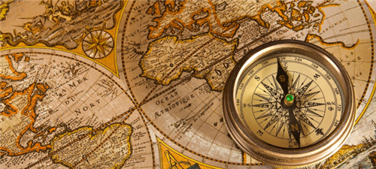 | World History  Students will use a variety of intellectual skills to demonstrate their understanding of major ideas, eras, themes, developments, and turning points in world history and examine the broad sweep of history from a variety of perspectives.
Standard 3:  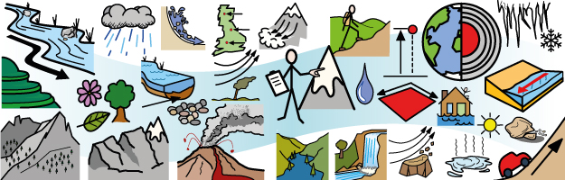 | Geography  Students will use a variety of intellectual skills to demonstrate their understanding of the geography of the interdependent world in which we live - local, national, and global - including the distribution of people, places, and environments over the Earth's surface.
Standard 4:   | Economics  Students will use a variety of intellectual skills to demonstrate their understanding of how the United States and other societies develop economic systems and associated institutions to allocate scarce resources, how major decision-making units function in the United States and other national economies, and how an economy solves the scarcity problem through market and nonmarket mechanisms.
Standard 5:  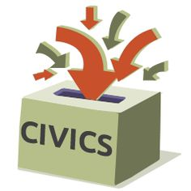 | Civics, Citizenship, and Government  Students will use a variety of intellectual skills to demonstrate their understanding of the necessity for establishing governments; the governmental system of the United States and other nations; the United States Constitution; the basic civic values of American constitutional democracy; and the roles, rights, and responsibilities of citizenship, including avenues of participation.

